All Data Structures Implementation in One Go –
1 - Linked List -
~1) LL Implementation
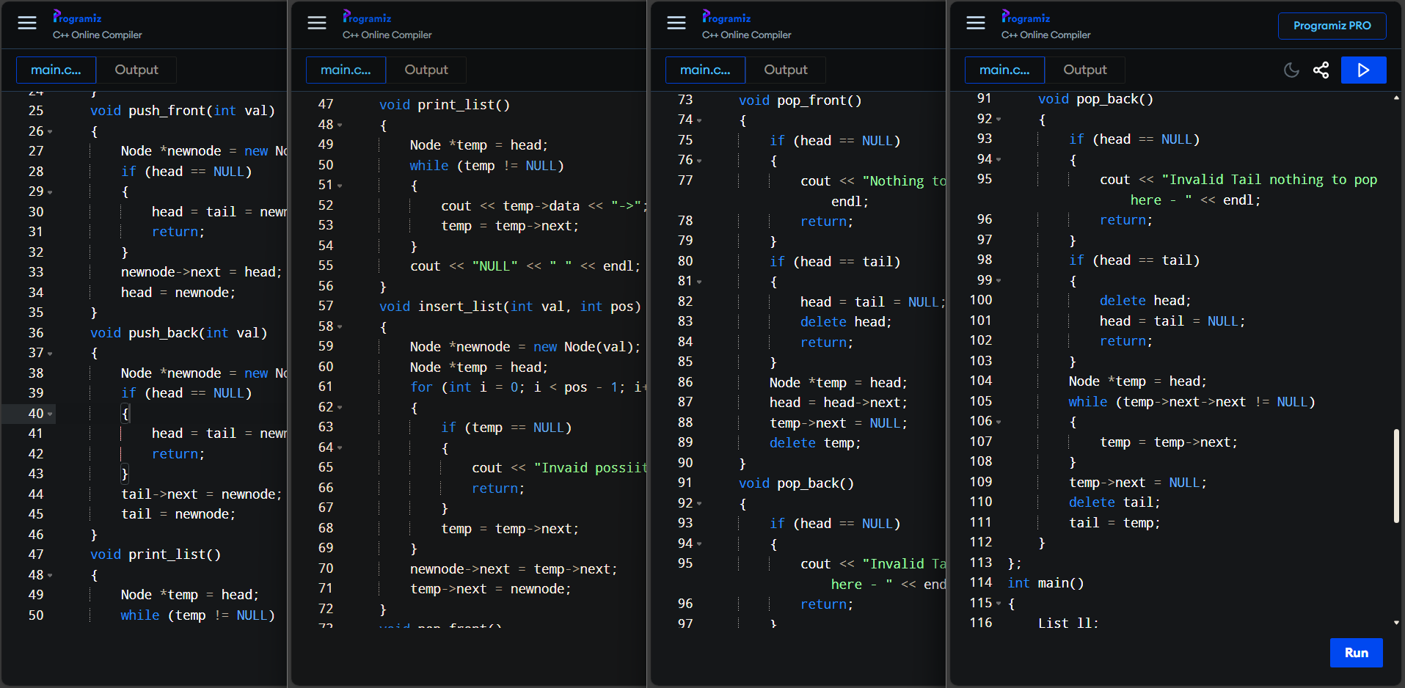
~1.1) DBLL Implementation
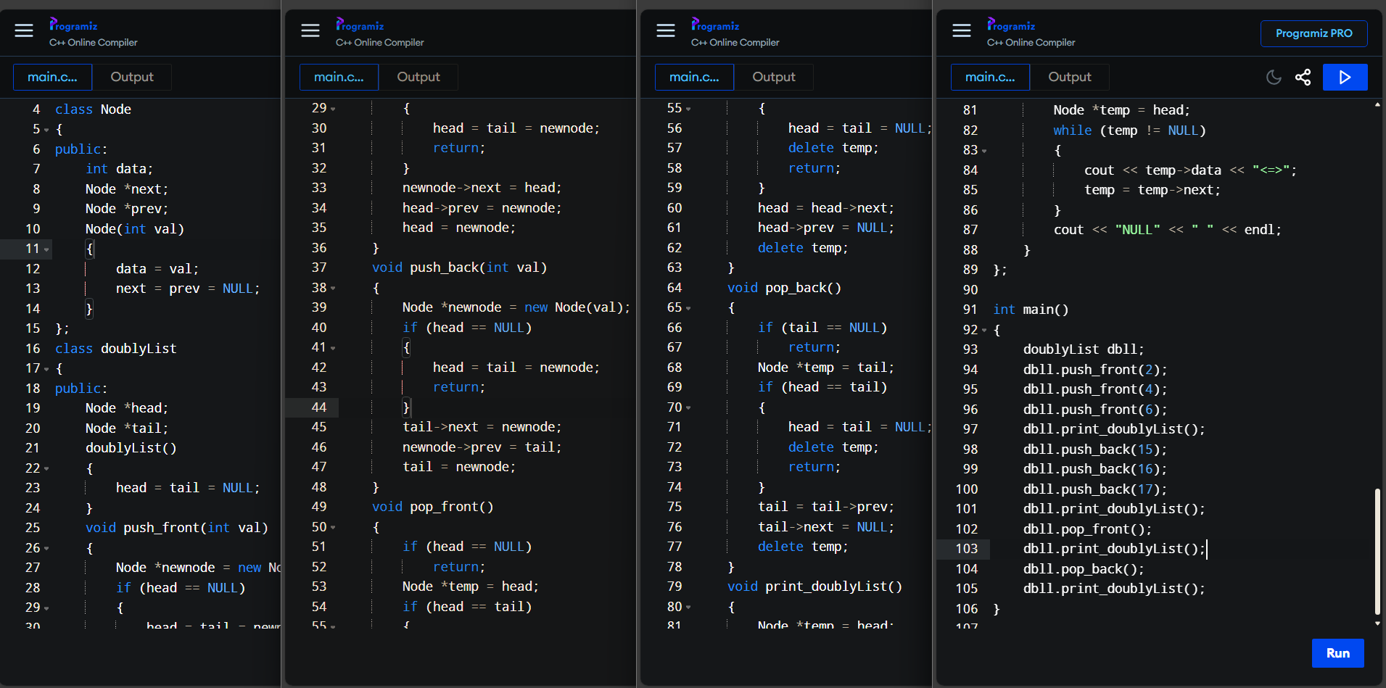
2 – Stack –
~2) Stack using LL Implementation
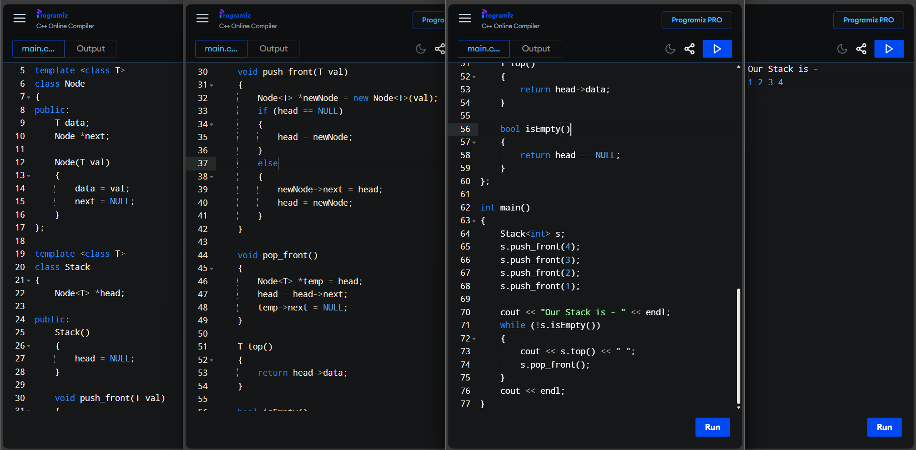
~2.1) Stack using vector Implementation
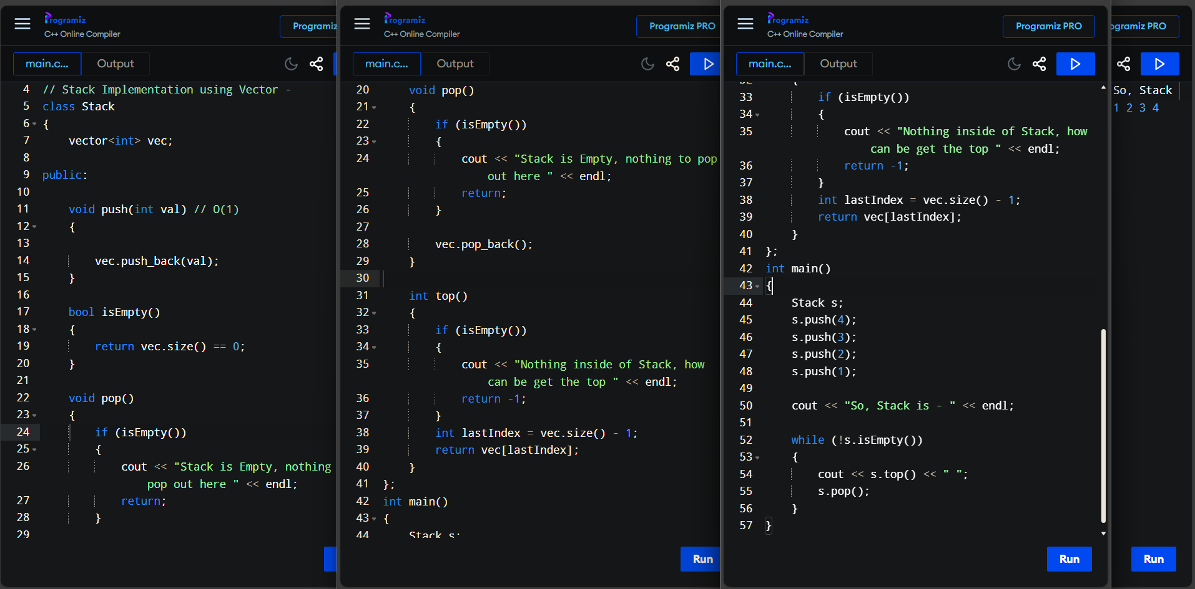
3 – Queue –
~3) Queue using LL Implementation
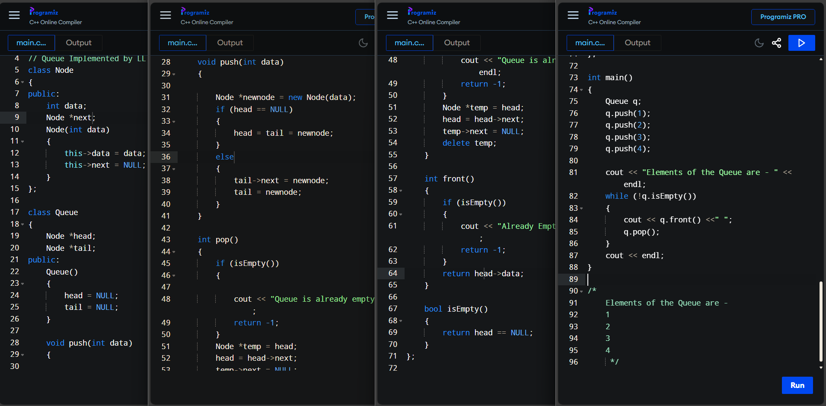
~3.1) Queue using vector Implementation
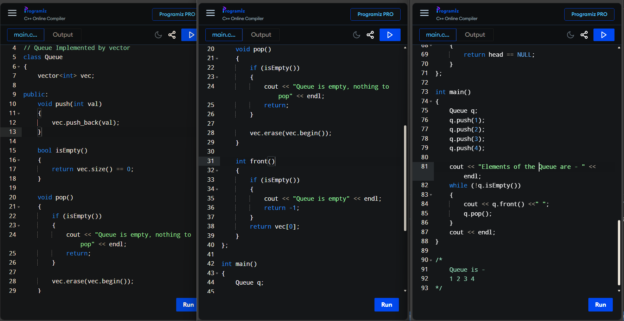
~3.2) Circular Queue Implementation
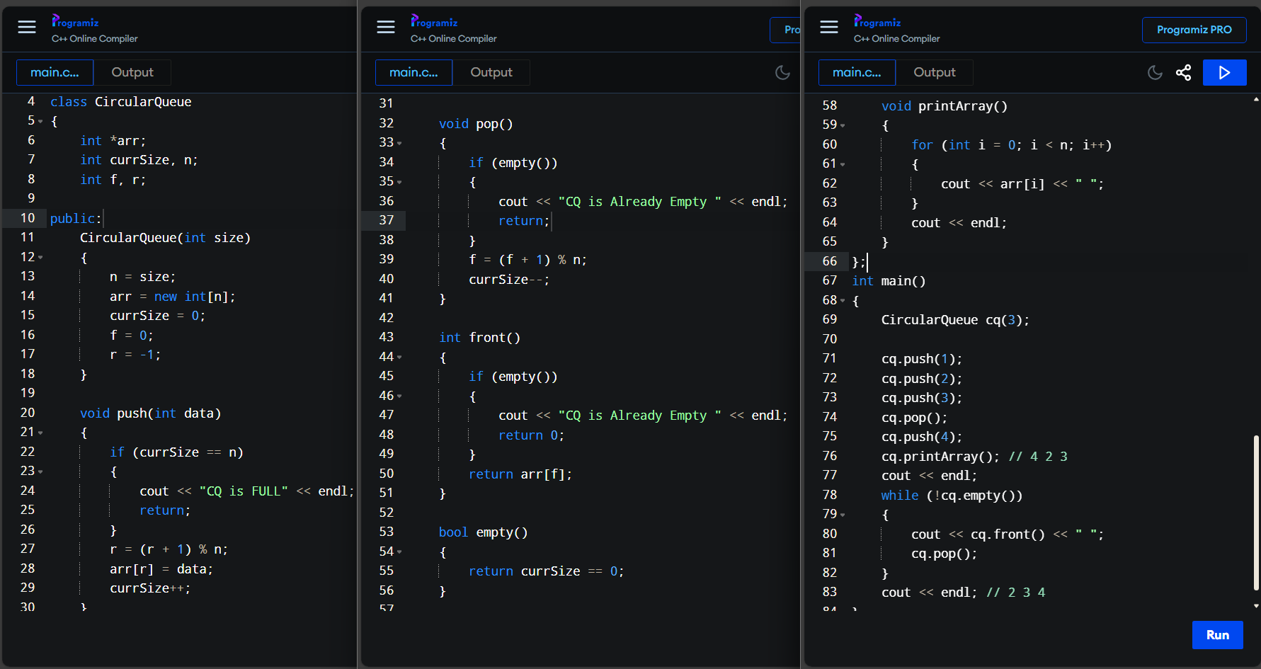
4 – Binary Tree –
~4) Binary Tree Implementation
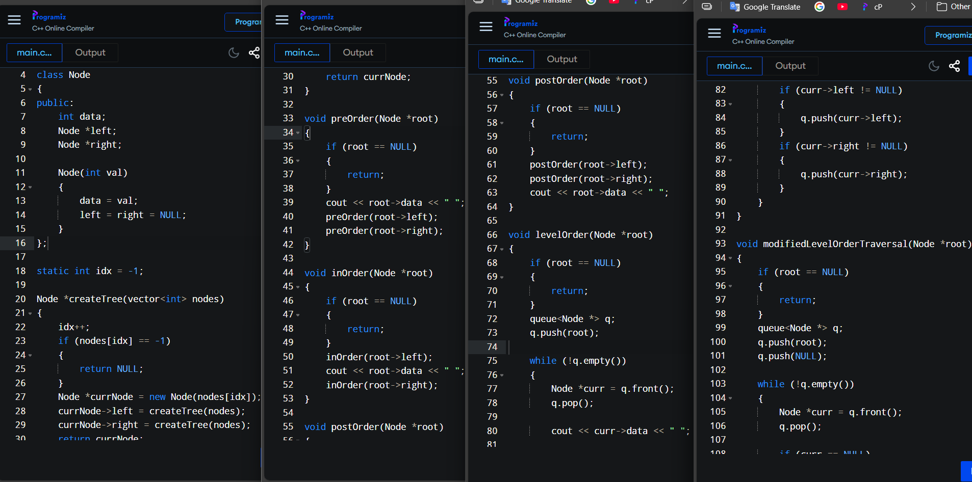
~4.1) Binary Tree All Functions
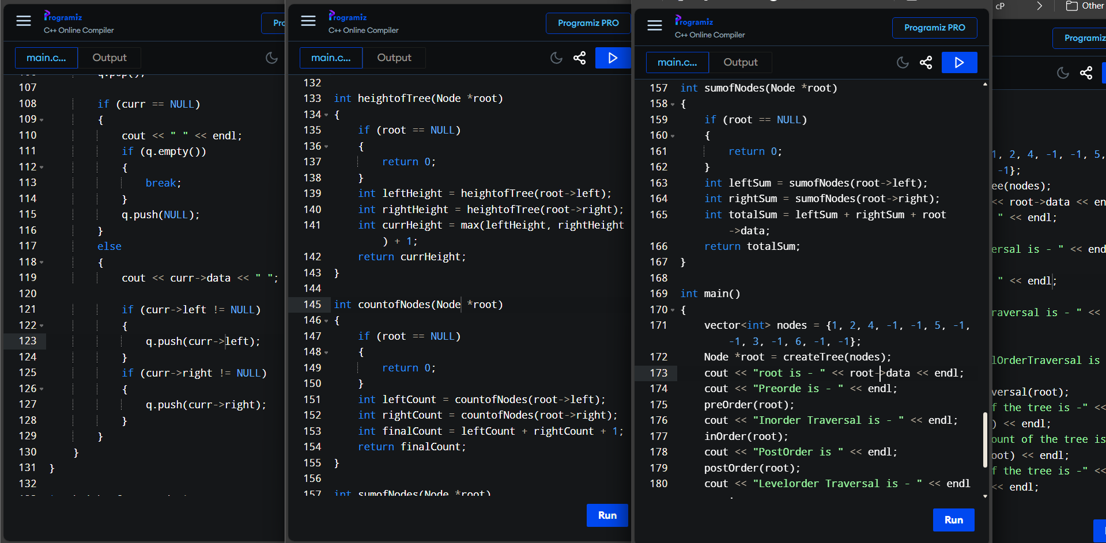
5 – BST –
~5) BST Implementation
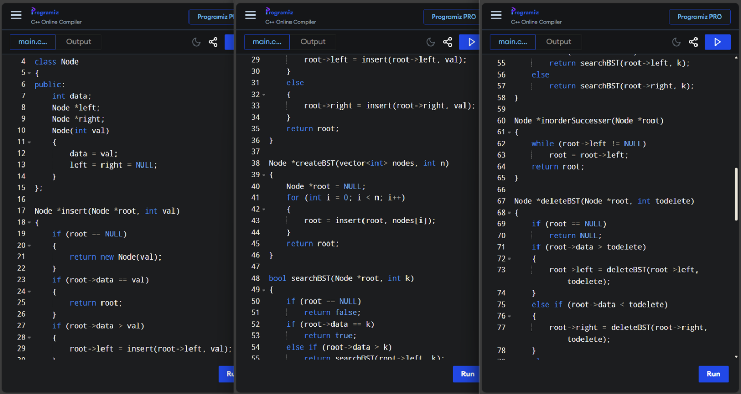
~5.1) BST Operations
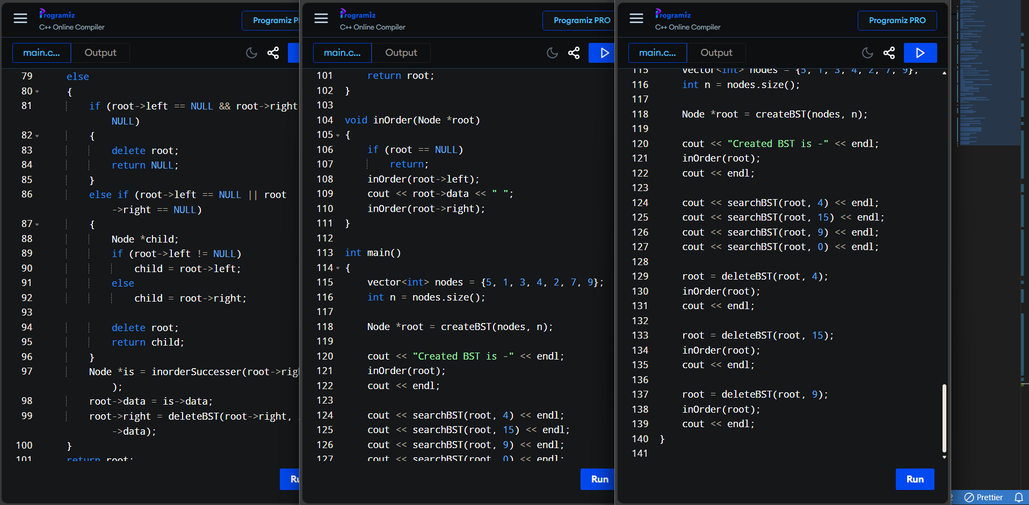
6 – Heap –
~6) Heap Sort Implementation
